# Part 2: Implementing and Analyzing Cache Configurations in gem5

Screenshots



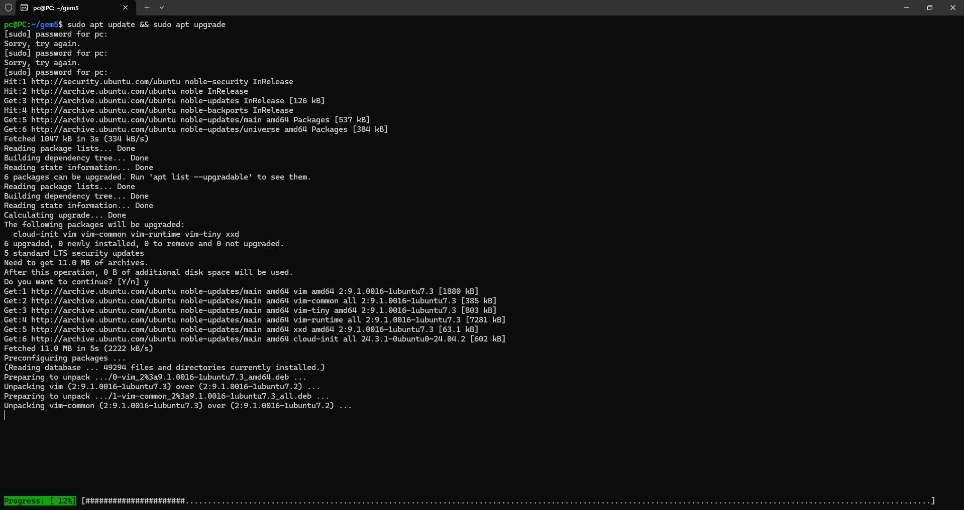

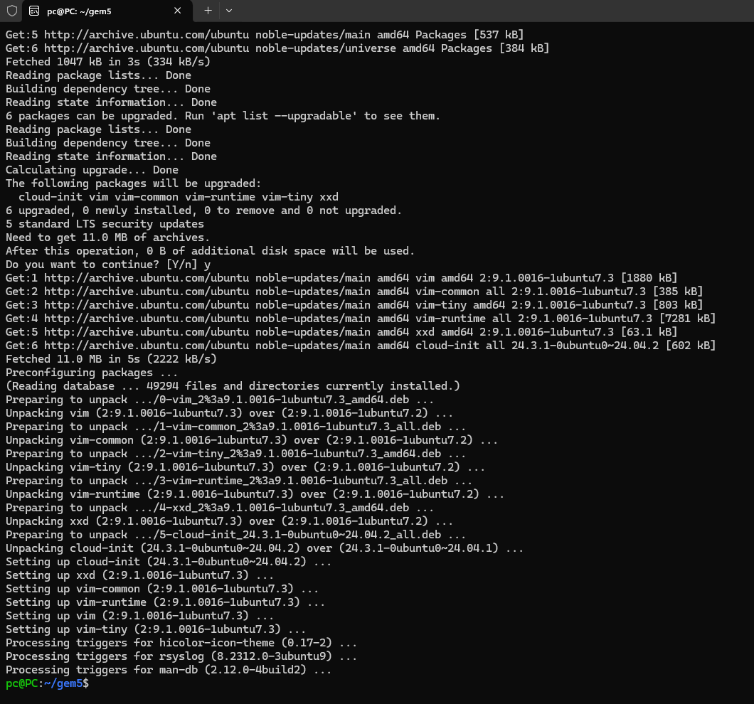

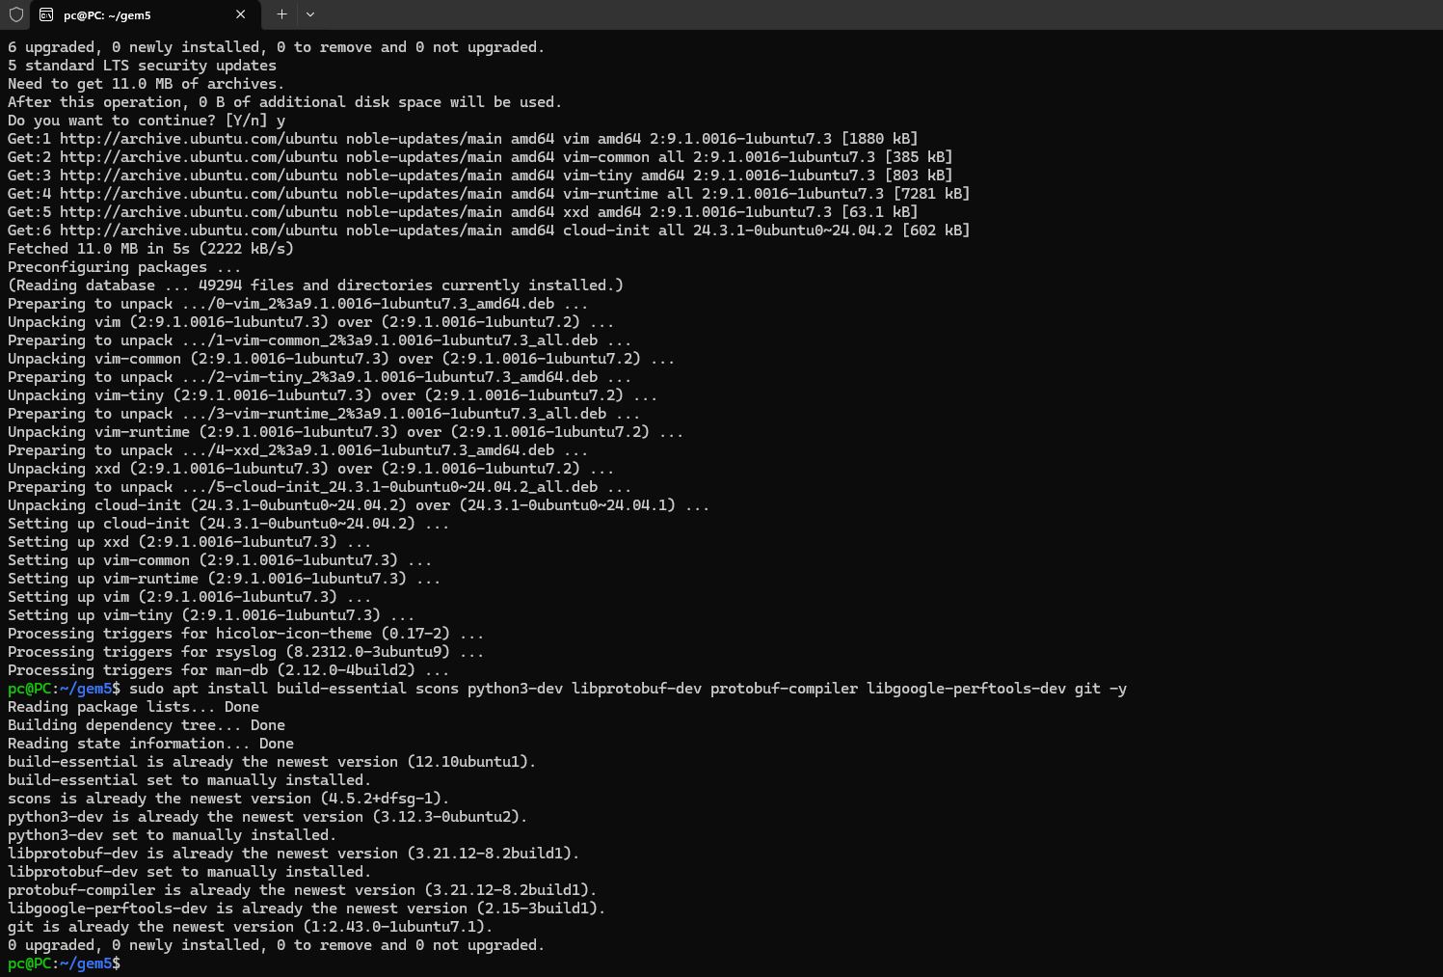

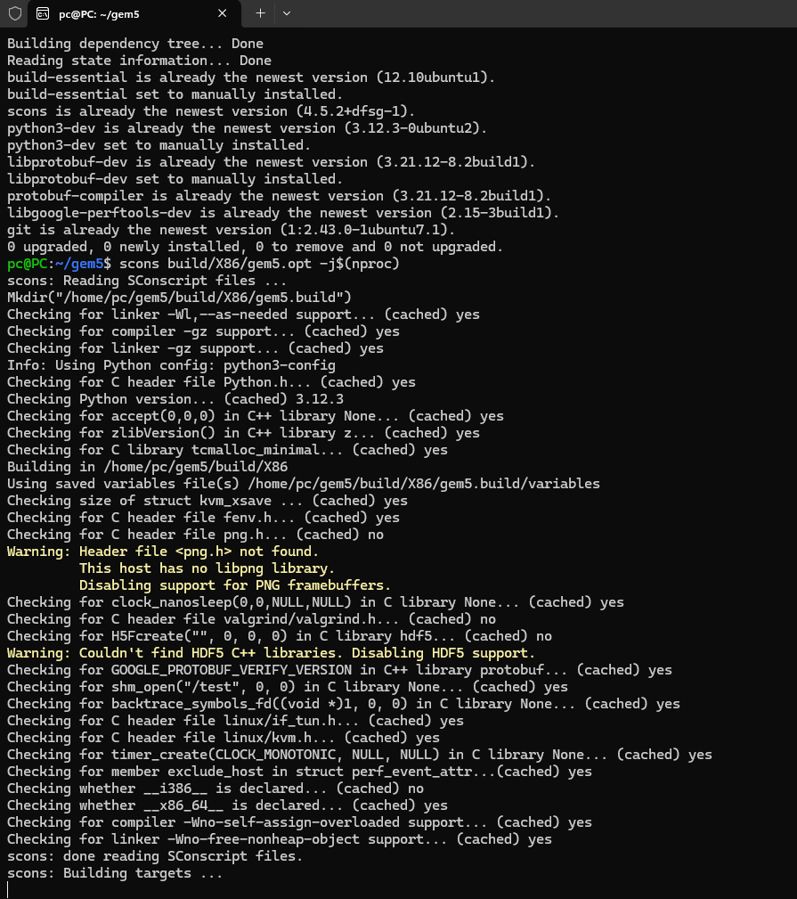

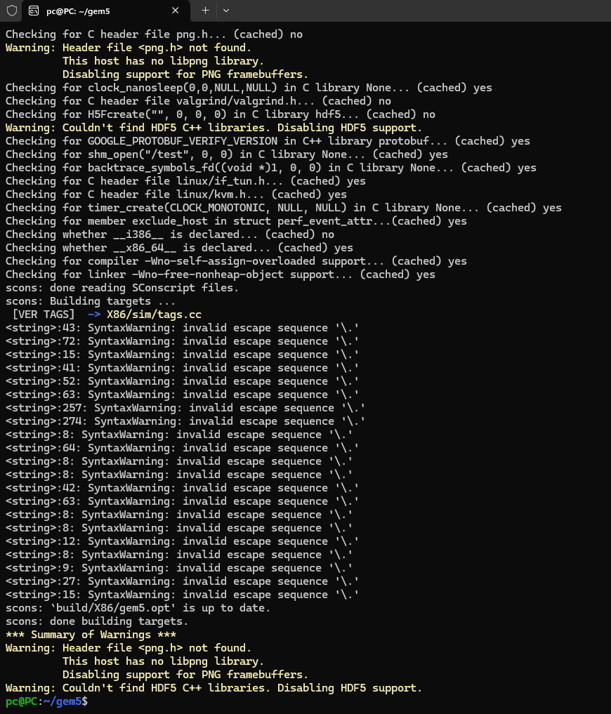

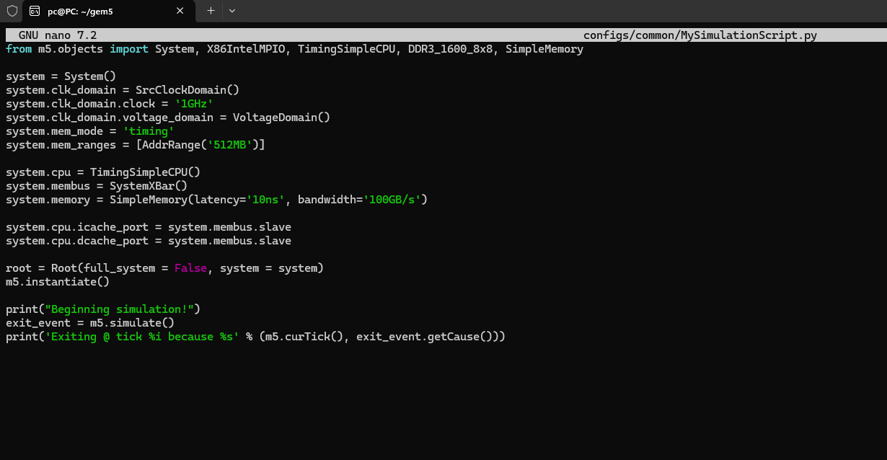

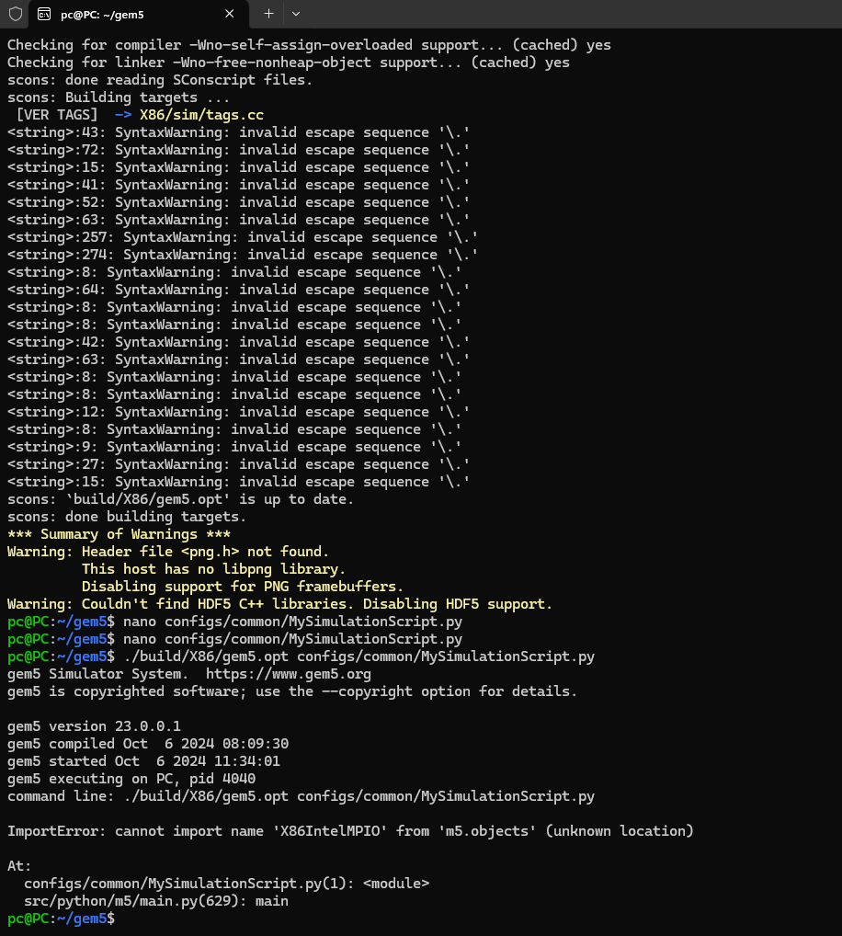

The gem5 simulator is an essential instrument for examining the complexities of memory hierarchy design and is extensively used by academics and educators to simulate many configurations of computer systems. This guide seeks to elucidate the process of configuring gem5, doing simulations centered on cache settings and virtual memory, and evaluating their effects on system performance.

The first step is configuring your machine for the installation of the gem5 simulator. It is vital to commence by updating and upgrading the existing packages on your Ubuntu system to guarantee that all software is up to date. This is followed by the installation of essential dependencies, including GCC, Python, SCons, and development libraries such as protobuf, which are vital for the construction and operation of gem5. After preparing the environment, you will clone the gem5 repository from its official source and build it, a procedure that may need some time based on the system's specifications.

Configuring gem5 requires the creation and modification of a Python script that delineates the system components, their attributes, and interactions. This script is often located in the configs/common directory and encompasses the definition of a fundamental system with x86 architecture. The script delineates parameters such as the system clock, memory mode, CPU type, and memory bus. This configuration includes specifying the cache and memory parameters, including latency and bandwidth, crucial for accurately mimicking system behavior.

To assess the cache subsystem's influence on performance, begin using gem5's default cache configurations, documenting baseline data like cache hit rates, miss rates, and average memory access latency. Subsequent simulations include methodically adjusting cache parameters—size, associativity, and block size—to analyze performance fluctuations. Every modification is carefully recorded to monitor its impact on system efficiency, offering insights into how various cache settings might mitigate the performance disparity between the CPU and main memory.

Investigating virtual memory requires altering the setup script to activate virtual memory and adjusting settings such as page sizes and TLB configurations. Simulating various configurations aids in evaluating the system's memory management efficiency, with special emphasis on measures such as page fault rates and TLB miss rates. These measurements are essential for evaluating the efficacy of virtual memory in contemporary operating systems and its influence on overall system performance.

The concluding stage entails thorough documenting of all operations, setups, and results. This documentation serves as a comprehensive examination of the rationale behind certain settings and their effects on system performance. It encompasses graphical representations that visually condense data, facilitating the interpretation of outcomes. The insights obtained from these simulations are associated with theoretical notions, improving the comprehension of memory hierarchy design. This comprehensive analysis enhances learning and facilitates the identification of topics for more study, perhaps resulting in advancements in practical systems.

This method offers a comprehensive framework for using gem5 to investigate and comprehend intricate ideas of computer architecture by thoroughly recording every stage of the setup, configuration, simulation, and analysis. This expertise is essential for anybody seeking to enhance their comprehension or contribute to progress in computer systems design.